Part1: Detailed initial analysis of data set



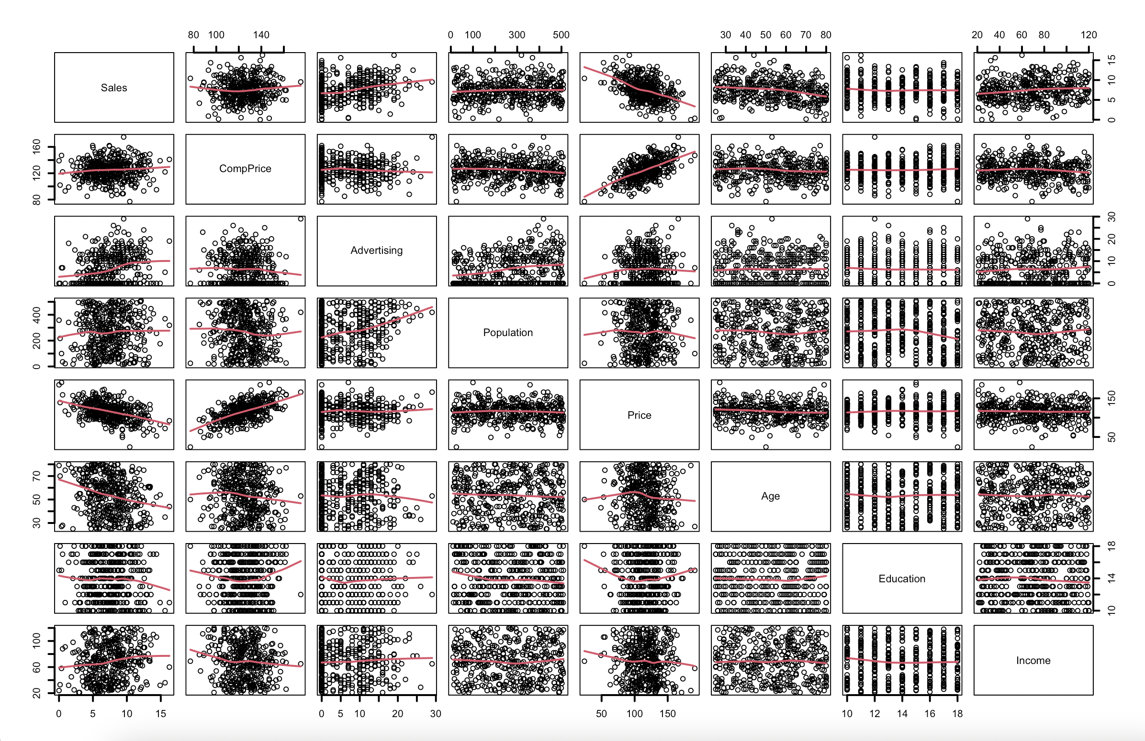

The predictor variable Price has a strong negative relationship with the response variable Sales. The predictor variables Price and CompPrice have a strong positive relationship with each other. There does not seem to be any other strong relationships between any other variables. Not all relationships are linear.

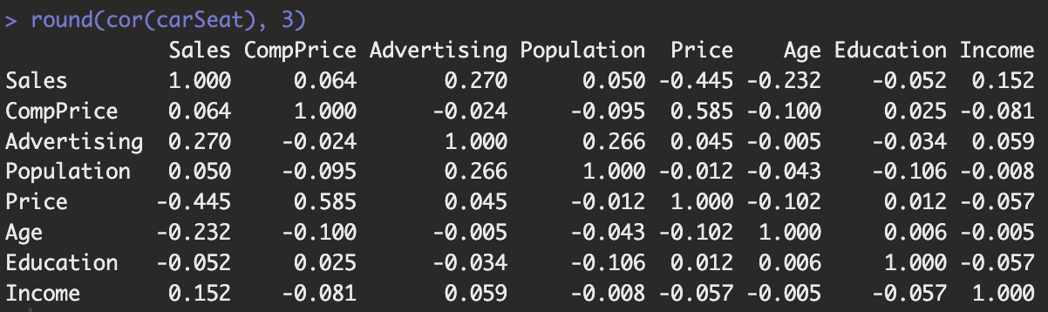

Sales and Price have a relatively strong negative correlation (-0.445). Other than the correlation a variable has with itself, CompPrice and Price have the strongest correlation with each other; a positive correlation (0.585). No other variables seem to have a considerably strong relationship with eachother.

An initial analysis of the full model, statistical significance

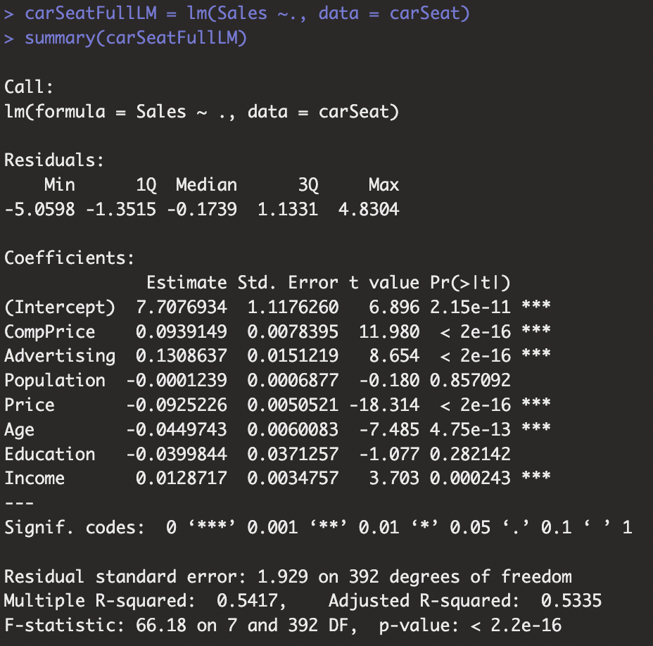

As the p value of the predictor variables CompPrice, Advertising, Price, Age and Income is < 0.05, I reject the null hypotheses that their coefficients are insignificant to the regression line in favor of them all being significant given that all the other variables are in the model; all coefficients of the predictor variables CompPrice, Advertising, Price, Age and Income have a meaningful effect in the response variable; Sales

As the F statistic is very large (F-stat: 66.18, p value <0.05), I reject the null hypothesis that the whole regression is insignificant, in favor of the whole regression being significant to the data; at least one of the explanatory variables are a predictor of the response variable when used in the form expressed in the multiple regression expression.

Details of how the predictors were chosen for the selected model: AIC

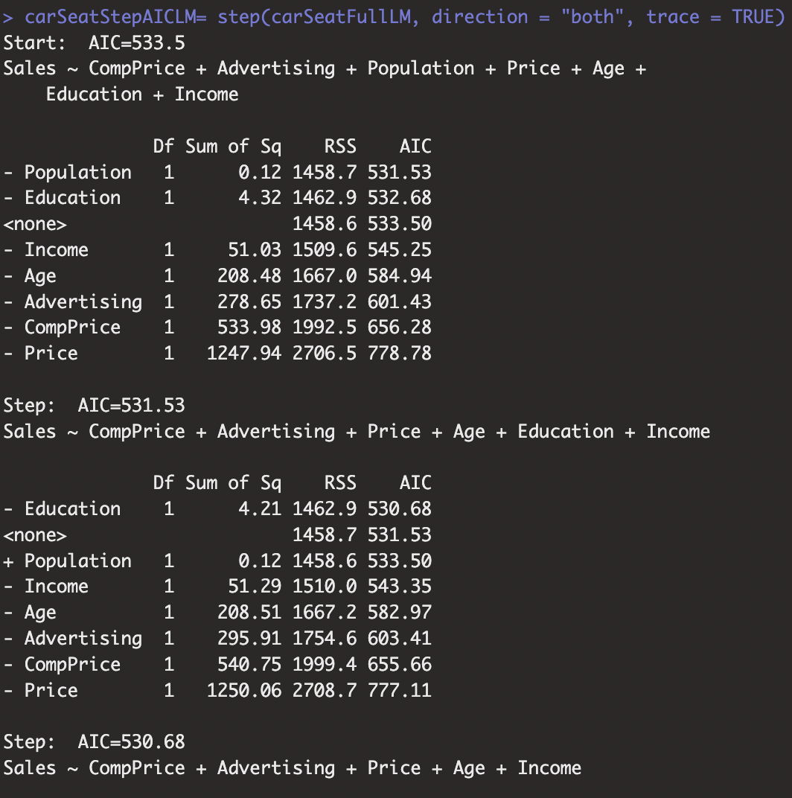

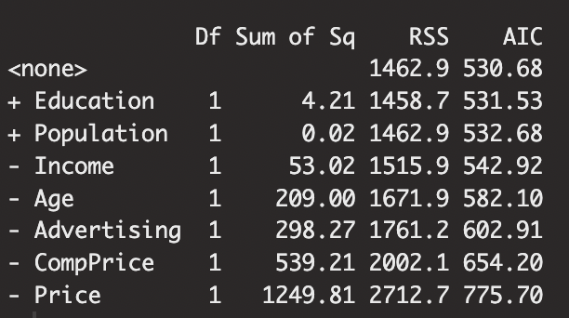

The best model using AIC decision criterion is the model including Income, Age, Advertising, CompPrice and Price as predictor variables and Sales as the response variable. This model has an AIC value of 530.68.

Details of how the predictors were chosen for the selected model: BIC

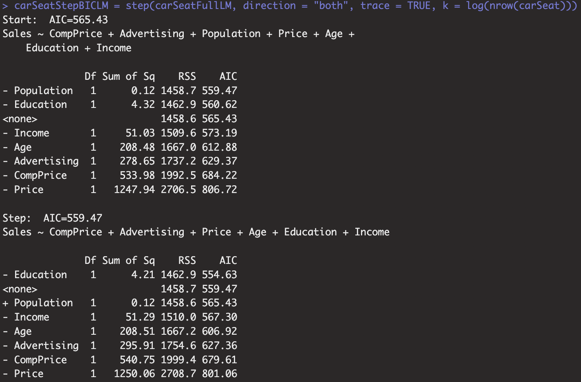

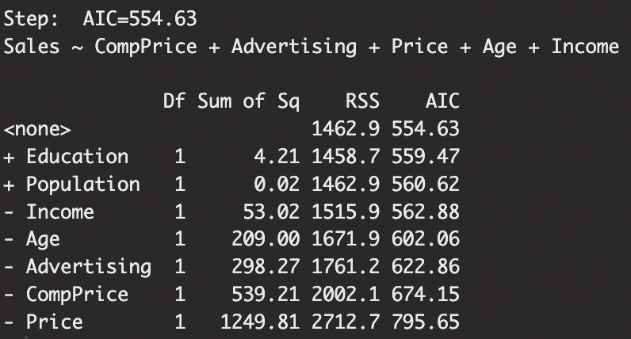

The best model using BIC decision criterion is the model including Income, Age, Advertising, CompPrice and Price as predictor variables and Sales as the response variable. This model has an BIC value of 554.63.

Details of how the predictors were chosen for the selected model: myallpossregs.func

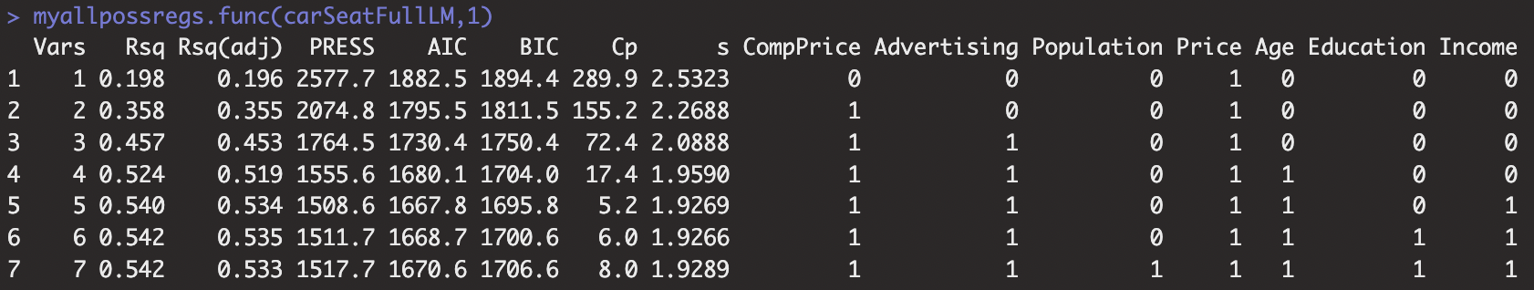

The best 1 variable model is model 1 which includes the predictor variable Price

The best 2 variable model is model 2 which includes the predictor variables CompPrice and Price

The best 3 variable model is model 3 which includes the predictor variables CompPrice, Advertising and Price

The best 4 variable model is model 4 which includes the predictor variables CompPrice, Advertising, Price and Age

The best 5 variable model is model 5 which includes the predictor variables CompPrice, Advertising, Price, Age and Income

The best 6 variable model is model 6 which includes the predictor variables CompPrice, Advertising, Price, Age, Education and Income

The best 7 variable model is model 7 which includes the predictor variables CompPrice, Advertising, Population, Price, Age, Education and Income

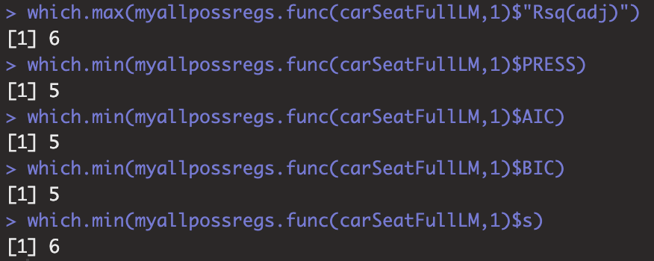

**Adj *R*2**: I would look for the model with the highest Adj *R*2 value as it would mean that that model explains the largest proportion of variation in the response variable which is adjusted for how many variables are used. With 6 variables, model 6 has the highest Adj *R*2 value (0.535).

**PRESS**: I would look for the model with the lowest PRESS statistic as it would mean that that model is the best model for prediction, because it has the lowest sum of squares of the deleted residuals. With 5 variables, model 5 has the lowest PRESS statistic (1508.6)

**AIC**: I would look for the model with the lowest AIC, because it would mean that the model no longer has any variables to add/remove that would improve the selection criterion, and because a lower criterion value is preferred. With 5 variables, model 5 has the lowest AIC (1667.8).

**BIC**: I would look for the model with the lowest BIC, because it would mean that the model no longer has any variables to add/remove that would improve the selection criterion, and because a lower criterion value is preferred. With 5 variables, model 5 has the lowest BIC (1695.8).

**S**: I would look for the model with the lowest residual standard error because it would mean that that model has the least amount of unexplained variation in the residuals. With 6 variables, model 6 has the lowest residual standard error (1.9266).

Details of how the predictors were chosen for the selected model: Mallow’s *Cp*

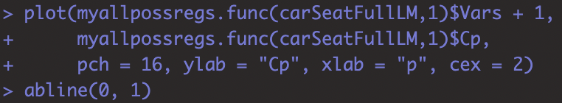

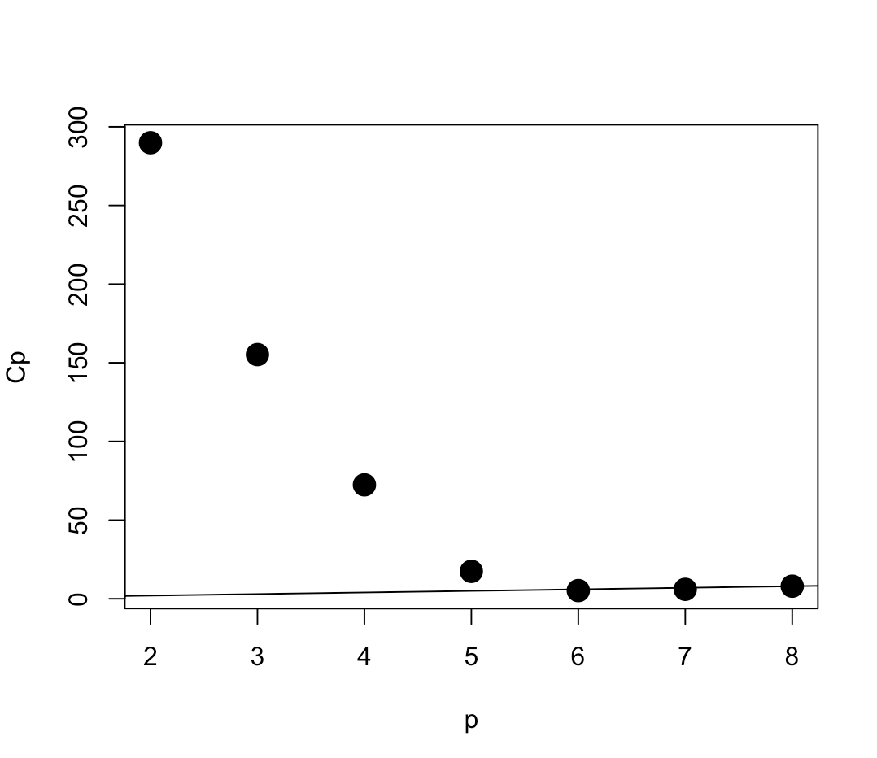

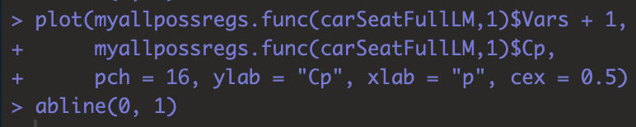

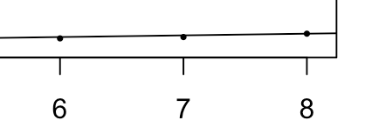

*Cp* : I would look for the model where *Cp*  is as small as possible, p is as small as possible, *Cp*  is near p, and where the model with smallest p also has *Cp*  lying below the line *Cp*  = p.



It seems that only models 5 and 6 lie below the line *Cp* = p (model 7 seems to lie on the line, not below it). As model 5 lies just slightly closer to p than model 6 and has the smallest *Cp* (5.2), *therefore a smaller *Cp* than model 6 (model 6 *Cp*: (6.0)), I conclude that model 5 has the best *Cp* (5.2).

Criteria/rationale used to determine the best model

I determine that model 5 is the best model because it wins on most of the criteria (4/6). It has the lowest PRESS, lowest AIC, lowest BIC and best *Cp*. Other than winning on the most criteria, another reason why model 5 is the best model is because in this context the researcher wants to **predict** the sales price of car seats, and this model includes the lowest PRESS statistic which is the best for making predictions out of all the criteria.

Error analysis of the chosen model (Model 5): Residual vs Fitted, Scale-Location, Residuals vs Leverage diagnostic plots

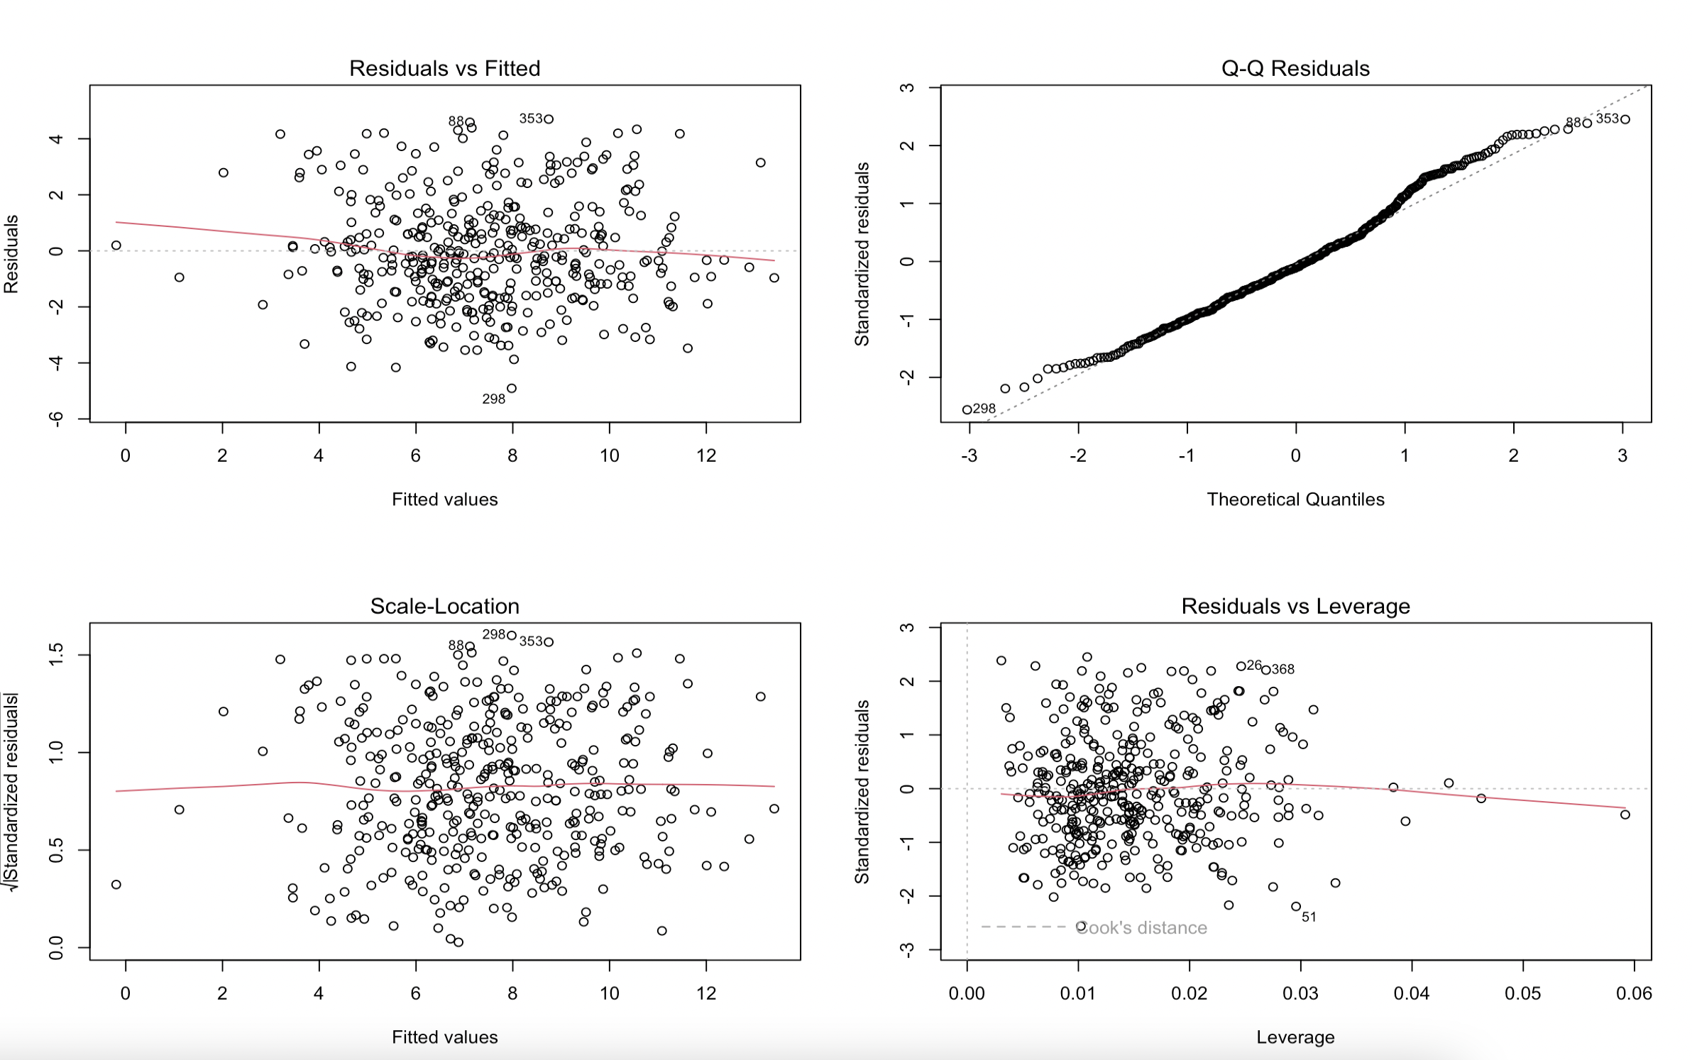

In the residual vs fitted plot, residuals have a constant scatter, there are no obvious non linear trends or clusters. There are no obvious outliers. All assumptions seem valid.

In the Scale-Location plot, there are no obvious trends in the data and the line is horizontal, so we can assume constant variance. All assumptions seem valid.

In the residuals vs leverage plot, all standardised residuals lie within the 0.5 contour for Cook’s distance meaning there are no extreme outliers within the data. All assumptions seem valid.

Error analysis of the chosen model (Model 5): Q-Q plot, histogram, Shapiro Wilk test



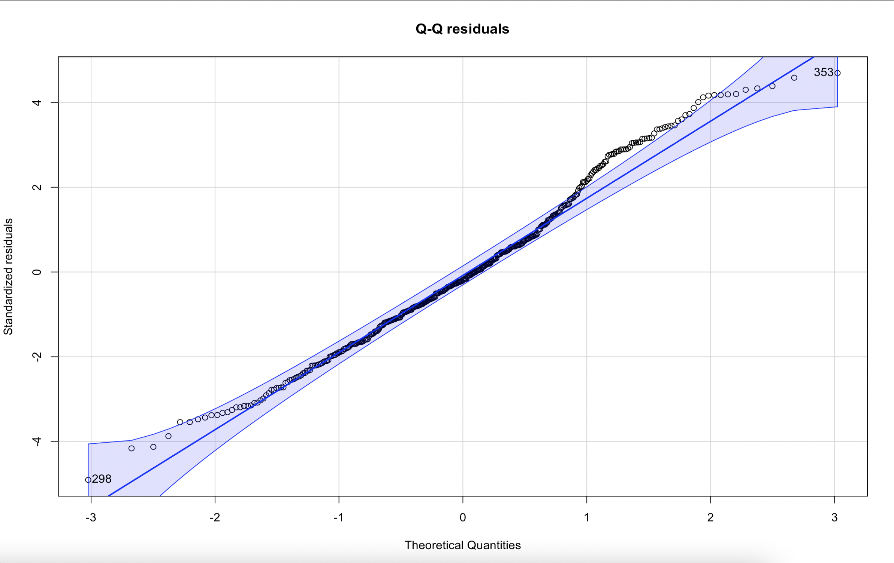

In the qq plot, points lie close to the line near the middle but start to vary away from the line in a non-normal pattern at the extremes, especially the right side where the points all lie above the line and outside of the confidence interval bound. This could imply non-normality in the residuals.

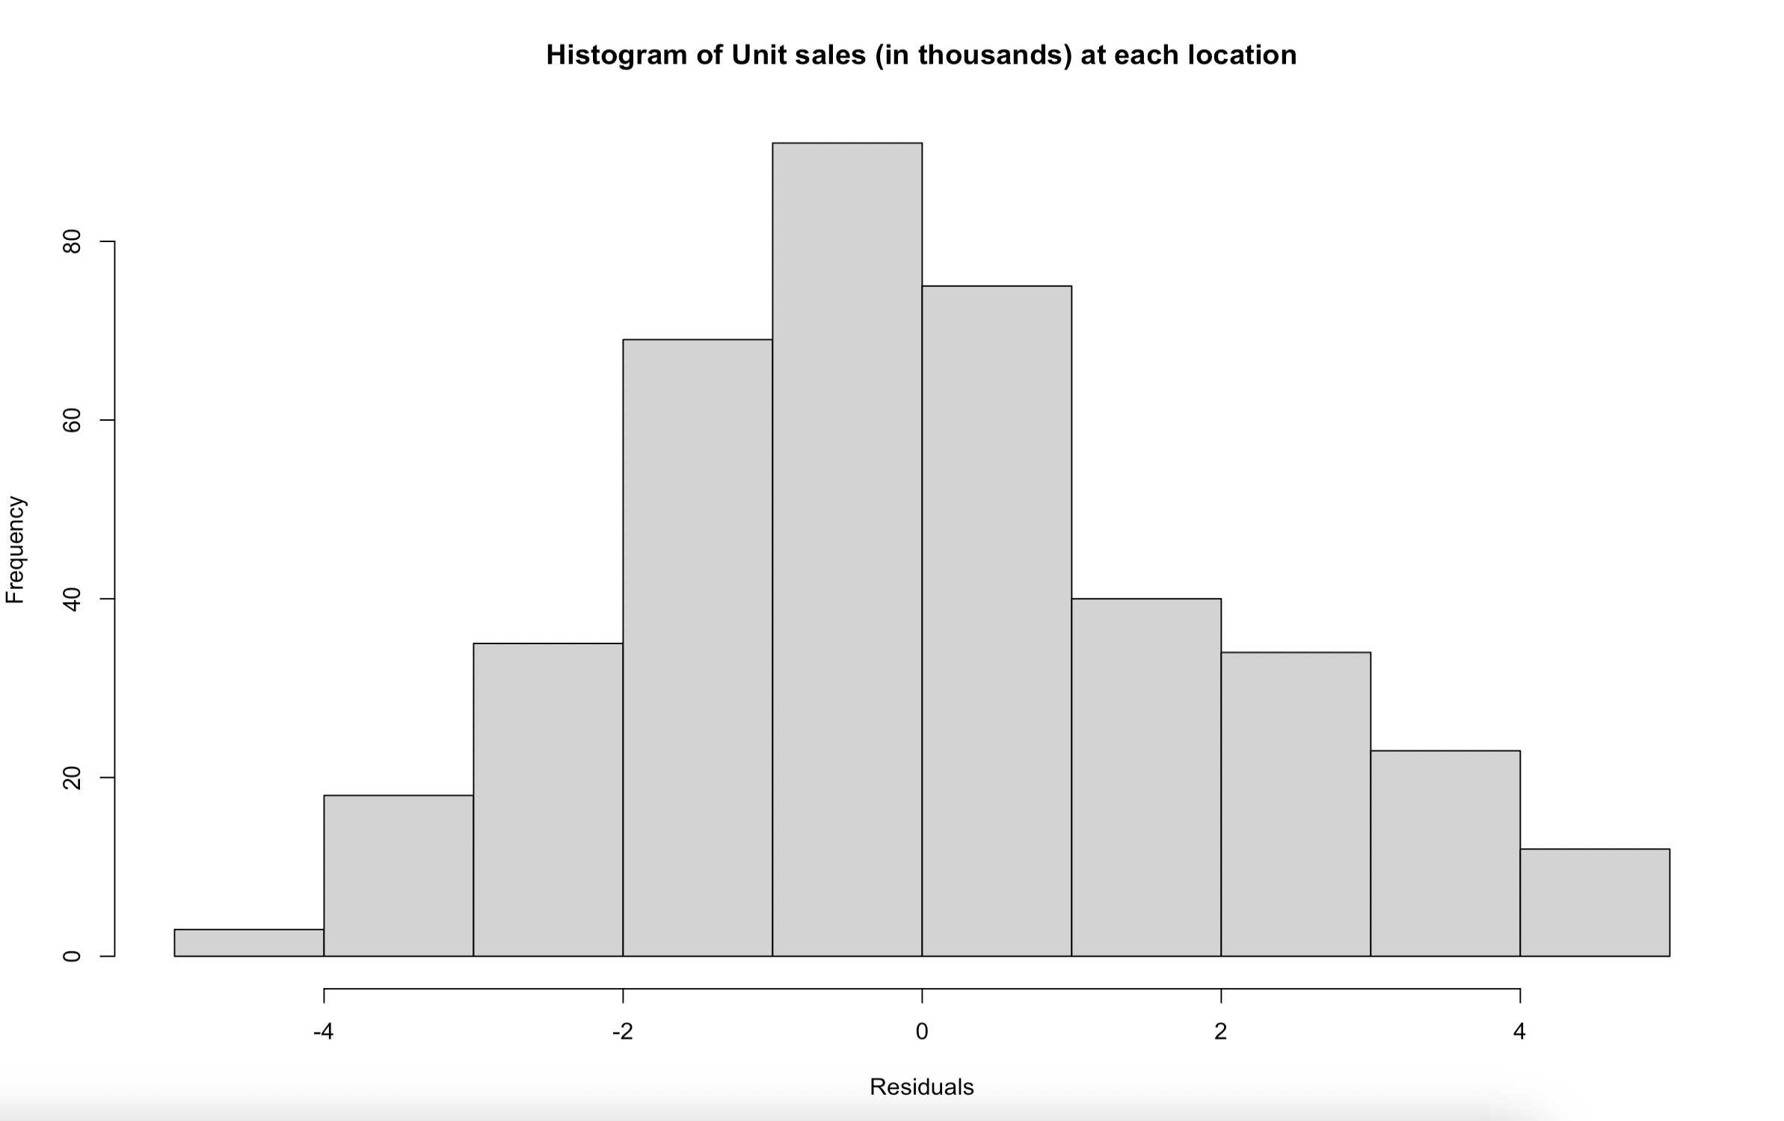

In the histogram the data looks fairly symmetric, but with a very slight skew and not normally distributed. This implies non-normality.

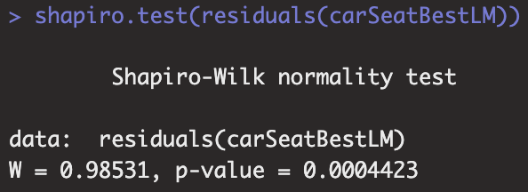

Since the P value of the Shapiro test < 0.05, I reject the null hypothesis that the data comes from a normal distribution in favor of the data not coming from a normal distribution. Due to all of these results, **we cannot assume normality; data is not normal**. Invalid assumption.

A conclusion of the results within the context of the problem

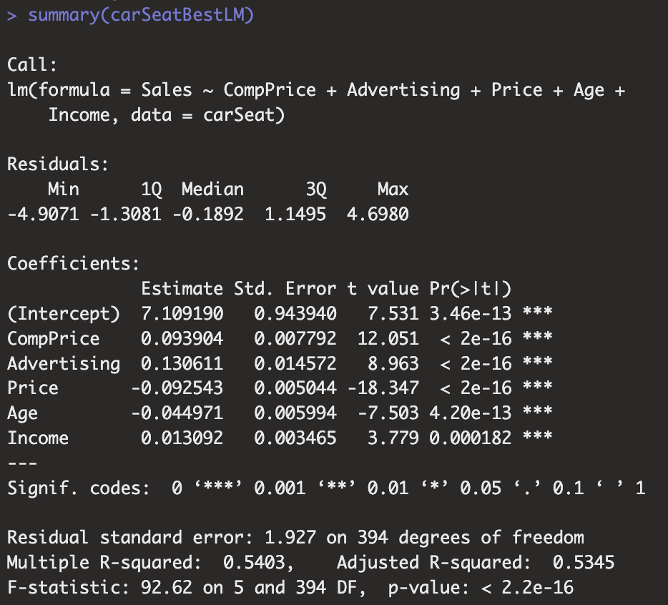

As the p value of all variables in this regression model is < 0.05, I reject the null hypotheses that their coefficients are insignificant to the regression line in favor of them all being significant given that the other variables are in the model; all coefficients have a meaningful effect in the response variable; Sales

As the F statistic is very large (F-statistic: 92.62, p value < 0.05), I reject the null hypothesis that the whole regression is insignificant, in favor of the whole regression being significant to the data; at least one of the explanatory variables are a predictor of the response variable when used in the form expressed in the multiple regression expression.

In conclusion of the multiple regression analysis, I determine that the best multiple regression model for modelling the sales price of car seats is model 5 which includes the predictor variables CompPrice, Advertising, Age and Income. All assumptions from the Residuals vs Fitted, Scale-Location and Residuals vs Leverage plots were met. From the results of the t-tests and the F-test; there is significant evidence to say that all coefficients in the model are significant and that the whole regression is significant to the data. However, from the Q-Q plot, histogram and Shapiro Wilk test, the residuals don’t seem to follow a normal distribution. As a result, the inference using t and F-tests and confidence and prediction intervals may not be reliable.

Part2: Initial analysis of the data

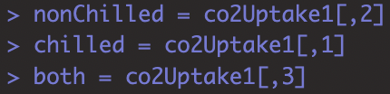

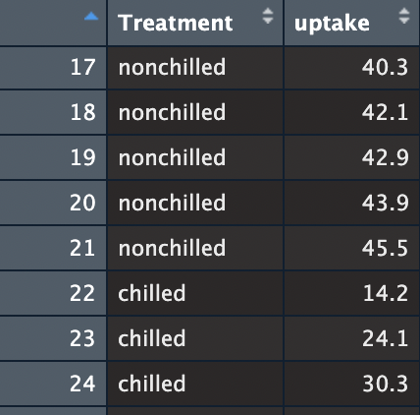 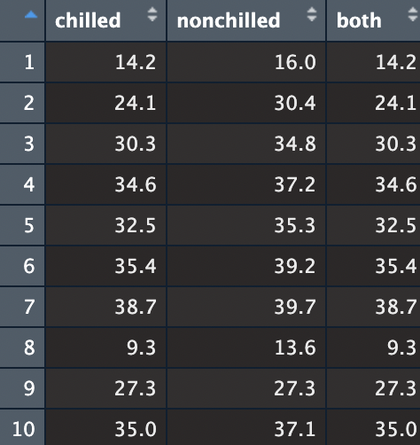

*Changed csv file to make nonchilled, chilled and both columns



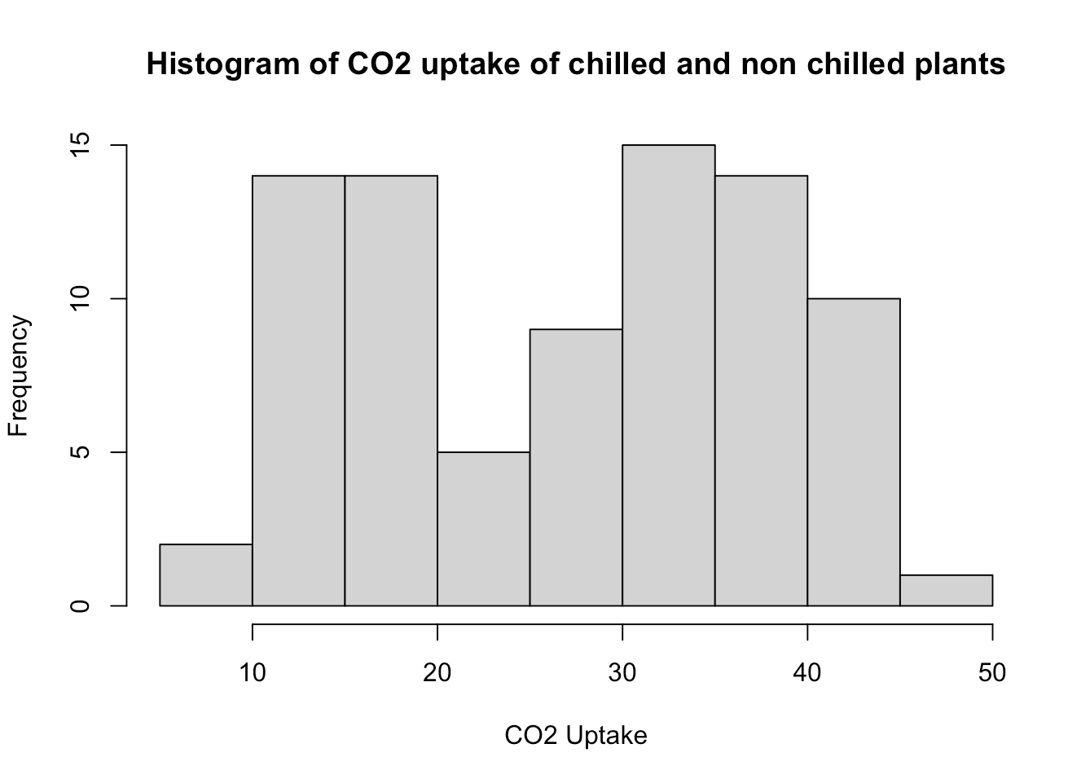 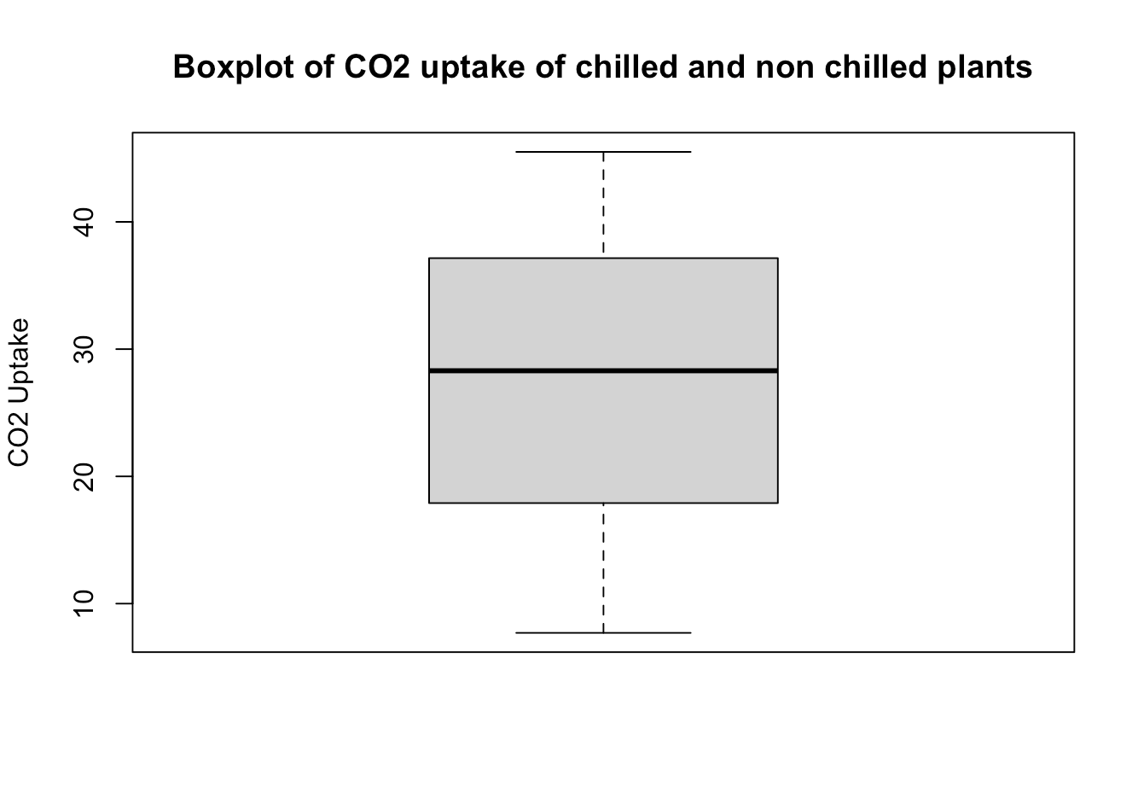

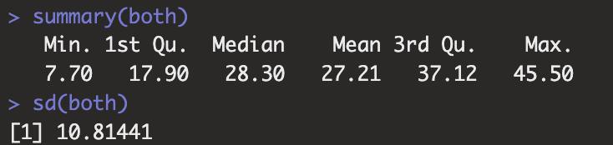

Looking at the histogram of CO2 uptake of both chilled and non-chilled plants, the shape looks to be bimodal as there are two prominent peaks at ranges of CO2 uptake 10-20 and 30-40 *μ*mol/*m^*2 sec. From the boxplot, the IQR varies within CO2 uptake of around 19-38 *μ*mol/*m^*2 sec. There does not seem to be any unusual qualities from the boxplot.

Noteworthy values from the summary statistics are the median (28.30 *μ*mol/*m^*2 sec), mean (27.21 *μ*mol/*m^*2 sec) and standard deviation (10.81441 *μ*mol/*m^*2 sec).

Choice of any and all tests used with justification, statement of the hypotheses, and printout of the results: Testing for normality (Histogram and QQ plot)

The data is the from related populations; types of plants from a certain grass species (which is being paired for similarity) and is being tested twice, before and after treatment (chilled and non-chilled). Therefore, we are dealing with dependent samples and should use the paired t-test. First, we need to check the normality assumptions.

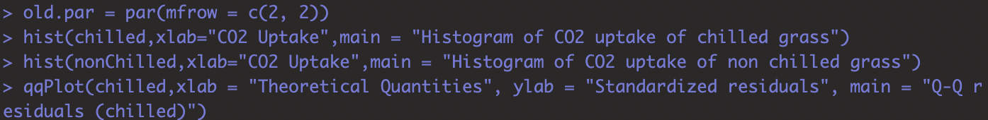

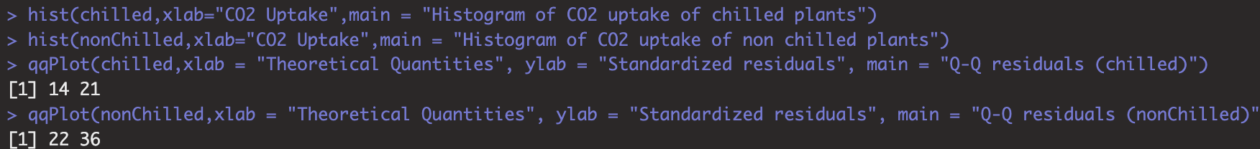

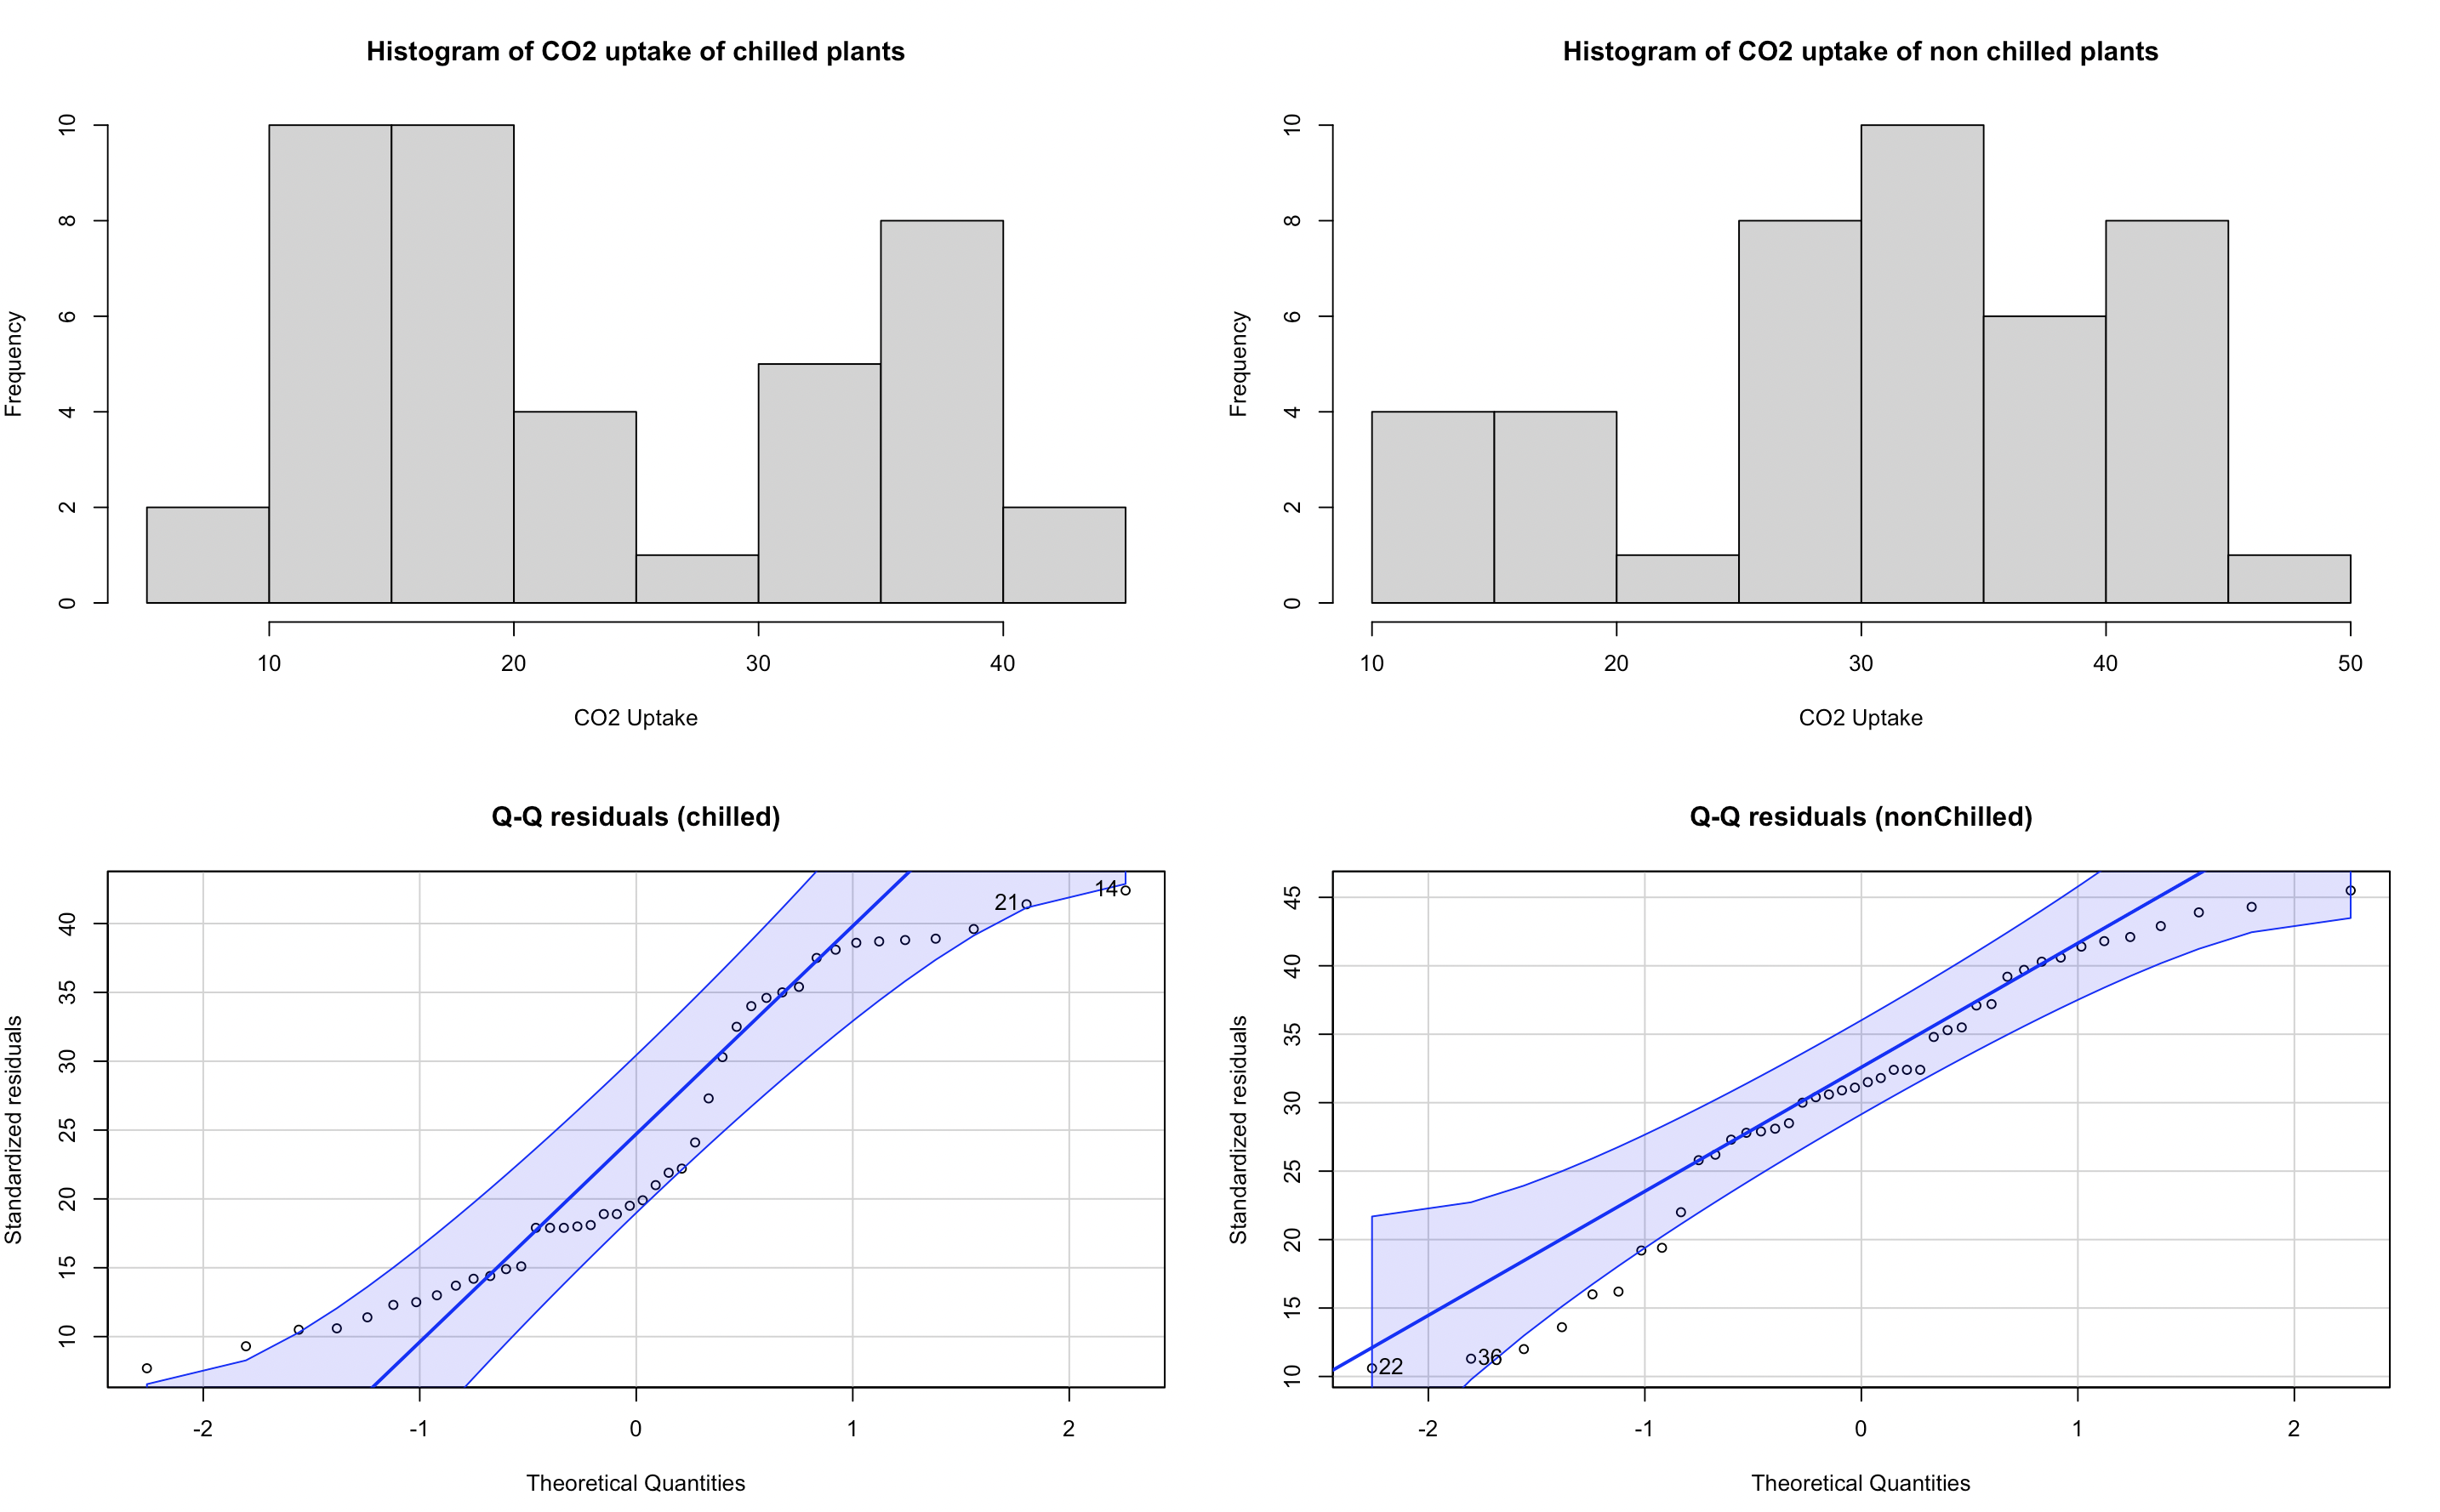

In the histogram for both chilled and non-chilled plants, data looks unsymmetrical and **not** normally distributed. Data in both histograms don’t seem to have a heavy skew in either direction because of smaller existing peaks on their tails, but if we are counting only prominent peaks, then I would say that the chilled plants histogram is bimodal while the non-chilled plants histogram is more unimodal. These observations imply non-normality.

In both QQ plots, points vary in a pattern-like way, lying close but then far away from the line which doesn’t seem random and implies a trend in the data, this is especially the case in the QQ plot for the chilled plants; a much more prominent, wave-like trend can be seen in the residuals. At the left extremes of both the QQ plots, a few points lie outside the confidence interval bounds. These observations imply non-normality in the residuals.

Choice of any and all tests used with justification, statement of the hypotheses, and printout of the results: Testing for normality (Shapiro Wilk test)

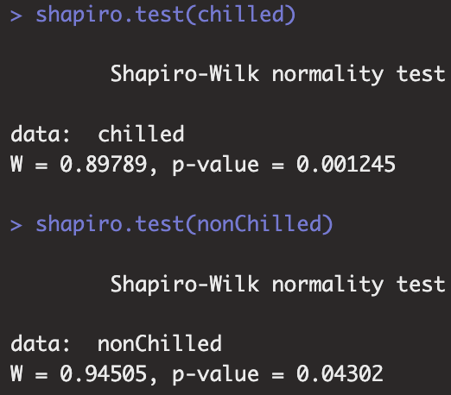

Since the P value for both Shapiro Wilk tests are < 0.05, I reject the null hypotheses that their data comes from a normal distribution.

Due to the results of the histograms, QQ plots and Shapiro Wilk tests, **we cannot assume normality; data is not normal.** Invalid assumption.

**However**, due to the robustness of t-tests to non-normality and the central limit theorem, we can still perform our paired t-test on our data **because** the sample sizes of both chilled and non-chilled plants are > 30 (42 samples for both), which provides the condition for the sample mean to follow a normal distribution.

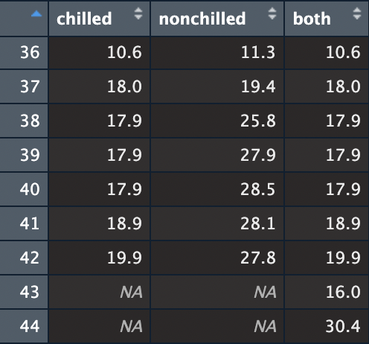

Choice of any and all tests used with justification, statement of the hypotheses, and printout of the results: Hypotheses and printout

As the researcher only wants to know if the chilled plants have a significantly different average CO2 uptake than the non-chilled plants, let the hypotheses be:

Let ud be the mean of the difference variable between CO2 uptake of chilled plants and non-chilled plants

Ho: ud = 0 vs Ha: ud != 0

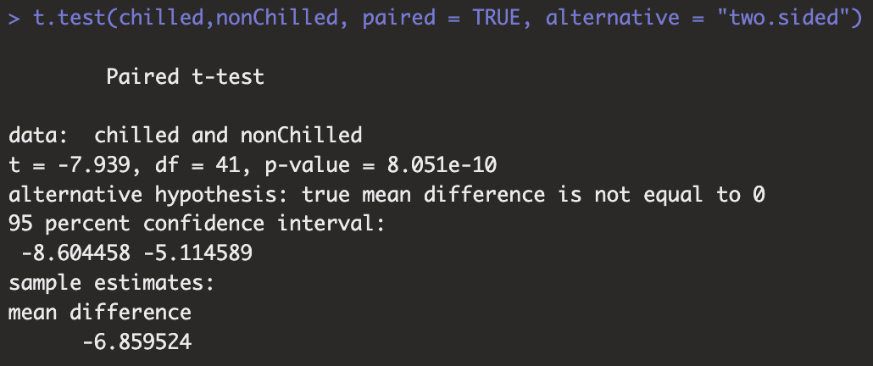

A summary of the results as well as the resulting decision and conclusion

Conducted a paired t-test on the mean difference variable between CO2 uptake of chilled plants and non-chilled plants, with null hypothesis being ud = 0 and alternative hypothesis being ud !=0. Resulted in a p-value of 8.051e-10.

Since p < 0.05, I have decided to reject the null hypothesis of the mean difference variable between CO2 uptake of chilled plants and non-chilled plants being equal to 0, in favor of it not being equal to 0.

In conclusion, I determine that there **is** **statistically significant** **evidence** to suggest a difference in the chilled plants and non-chilled plants; the chilled plants do have a significantly different average CO2 uptake than the non-chilled plants.